“Prediction of Disease Risk Using Logistic Regression Based on Height, Weight and Gender”

Prepared by:
Rajput Arpana Badshah

Abstract
This study aims to analyze the relationship between anthropometric variables such as height and weight, along with gender, in determining disease risk. The dataset was analyzed using statistical methods including independent sample t-test, chi-square test, and logistic regression.
The t-test results indicated a significant difference in mean weight between low-risk and high-risk groups, suggesting that weight plays an important role in risk classification. The chi-square test showed no significant association between gender and risk. Logistic regression analysis revealed that weight has a positive effect on risk, while height shows a negative effect, and gender has minimal influence.
The performance of the model was evaluated using a confusion matrix, which demonstrated high accuracy in classification. The findings of this study highlight the importance of weight as a key factor influencing disease risk.
Keywords: Disease Risk, Logistic Regression, t-test, Chi-square Test, Anthropometric Variables, Classification Model

Introduction
The analysis of disease risk factors is a fundamental aspect of biostatistics and epidemiological research. Identifying variables that significantly influence risk is essential for effective prediction and preventive strategies
In this study, statistical methods including hypothesis testing and logistic regression are employed to examine the relationship between these variables and disease risk. The objective is to determine significant predictors and develop a model for risk classification.

Data Description
The dataset used in this study consists of observations on four variables, namely Gender, Height, Weight and Index. Gender is a categorical variable representing the biological classification of individuals, while Height and Weight are continuous variables measured in centimeters and kilograms respectively.
The variable Index represents a categorical measure of health status. For the purpose of this analysis, a new binary variable termed Risk was derived from the Index variable. Individuals with higher index values were classified as high-risk, while those with lower values were categorized as low-risk.
The dataset comprises a total of 500 observations, providing sufficient information for statistical analysis and model building. Prior to analysis, the data were appropriately structured and transformed to ensure compatibility with statistical methods.

Methodology
In this study, statistical methods were applied to analyze the relationship between the variables and risk.
Independent sample t-tests were performed to compare the mean values of Height and Weight between the low-risk and high-risk groups.
A chi-square test of independence was used to examine the association between Gender and Risk.
Logistic regression analysis was carried out to study the effect of Height, Weight, and Gender on the probability of being in the high-risk group. The performance of the model was evaluated using a confusion matrix.

Implementation in R
1. Data Input
The dataset was imported into R using the read.csv() function. Initial inspection was performed using functions such as head(), names(), and summary() to understand the structure and variables in the dataset.
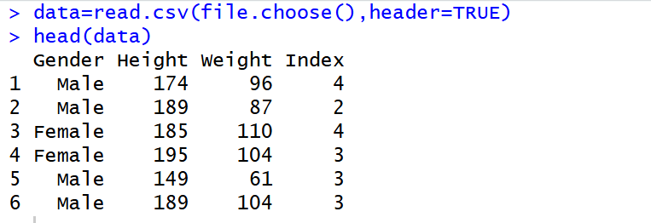

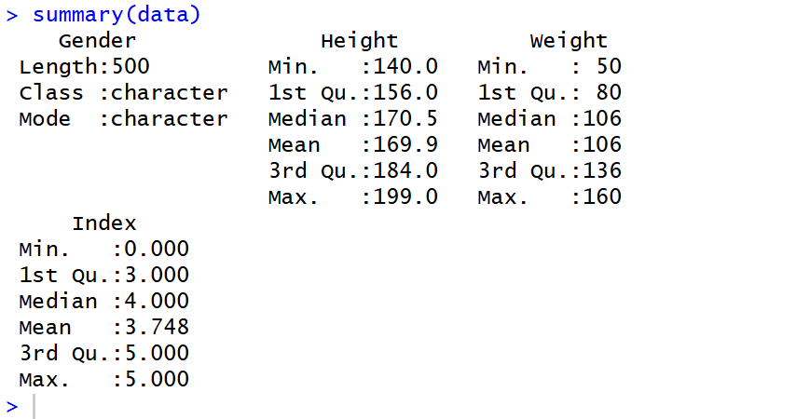

2. Distribution of Variables
The distribution of the Index and Risk variables was examined using frequency tables to understand the class balance in the dataset.
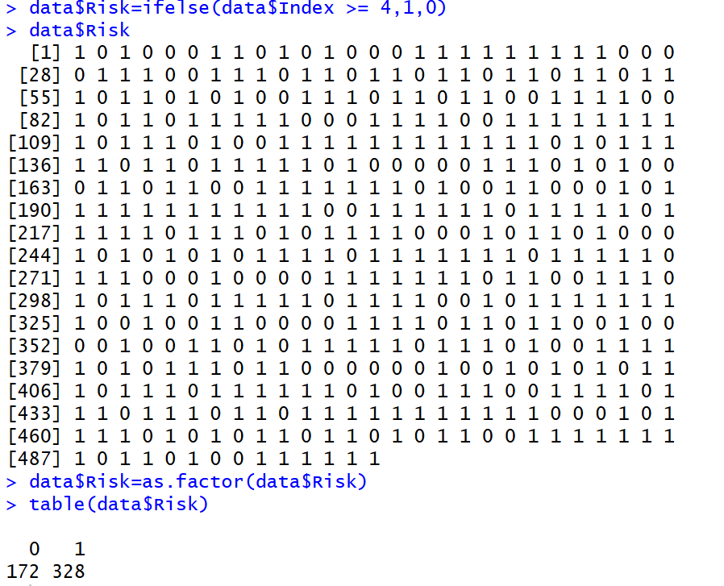
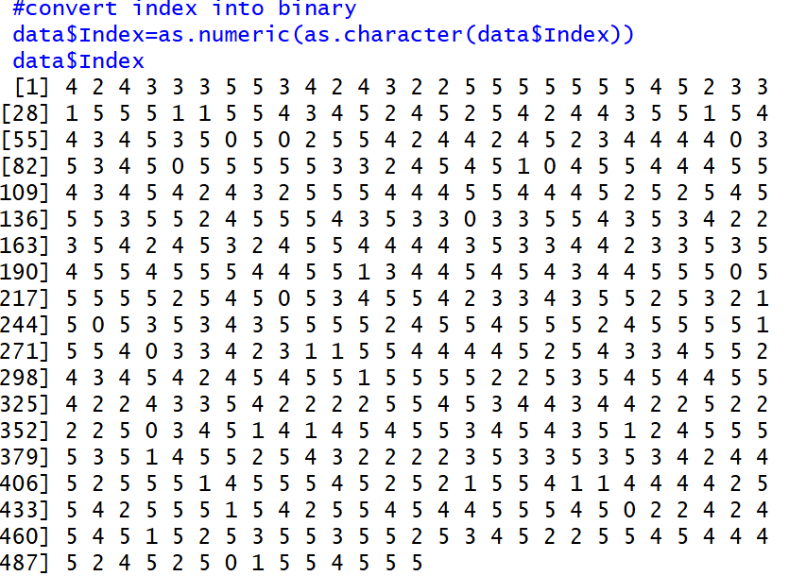

3. Exploratory Data Analysis (EDA)
3.1 Height Distribution
A histogram was plotted to visualize the distribution of the Height variable.
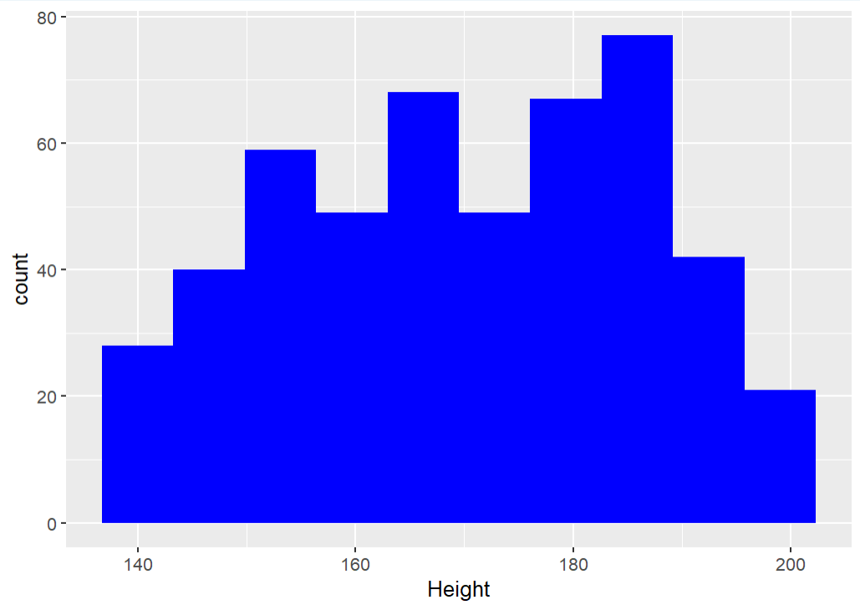

3.2 Gender vs Risk
A contingency table was created to examine the distribution of risk across gender categories.
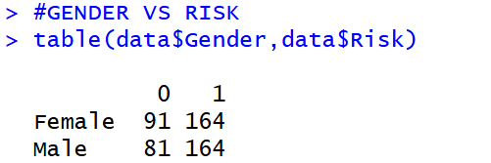

3.3 Weight vs Risk
A boxplot was used to compare the distribution of Weight between low-risk and high-risk groups.
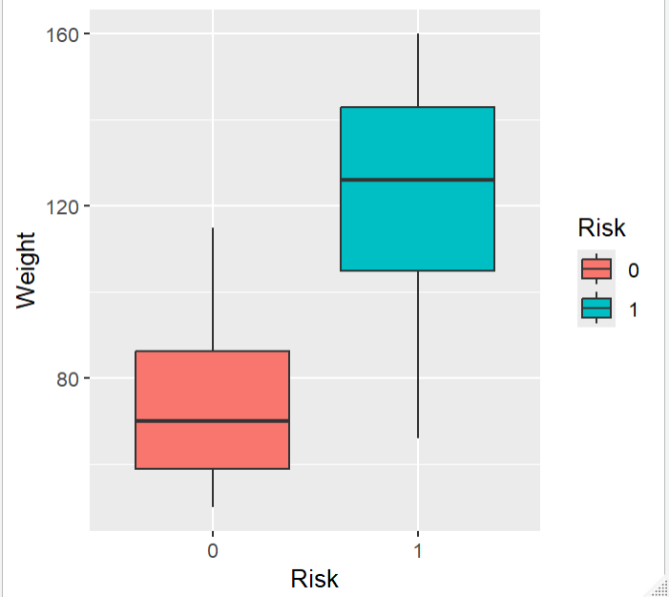

4 Statistical Analysis
4.1 t-test (Weight vs Risk)
An independent sample t-test was conducted to compare the mean weight between low-risk and high-risk groups.
Hypotheses
$$H_{0}:μ_{low}=μ_{high}$$Mean height is the same in both groups
$$H_{1}:μ_{low}≠μ_{high}$$ Mean height is different.
If p-value < 0.05:
There is a statistically significant difference in mean height between low-risk and high-risk groups.
If p-value ≥ 0.05:
There is no statistically significant difference in mean height between the groups.

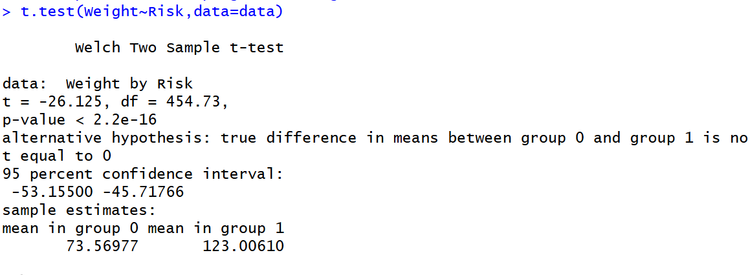
Interpretation
- value-2.2e-16 < 0.05 , fail to accept Ho , that is Mean is different.
- Insight from Means
Low risk mean = 73.57
High risk mean = 123.01
- Individuals in the high-risk group have significantly higher mean weight compared to the low-risk group, indicating that weight is strongly associated with risk.

4.2 Chi-square Test (Gender vs Risk)
A chi-square test of independence was performed to assess the association between Gender and Risk.

Hypotheses
$$H_{0}:\text{Gender and Risk are independent} \\ H_{1}:\text{Gender and Risk are associated}$$
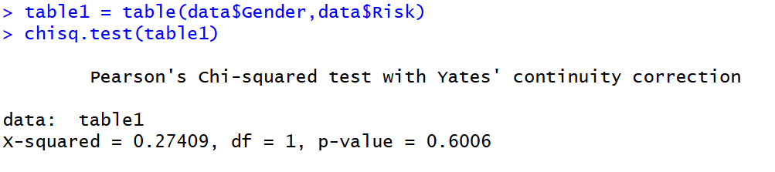
p-value-0.6006 >0.05, fail to reject Ho. There is no statistically significant association between gender and risk.

5. Logistic Regression Model , Prediction of Risk and Model Evaluation
Logistic regression analysis was performed to model the probability of being in the high-risk group using Height, Weight, and Gender as predictors. The model coefficients were exponentiated to obtain odds ratios, which help in interpreting the effect of each predictor on the risk.
Predicted probabilities were obtained from the logistic regression model and converted into binary outcomes using a threshold value of 0.5.
The performance of the model was evaluated using a confusion matrix by comparing predicted values with actual values.
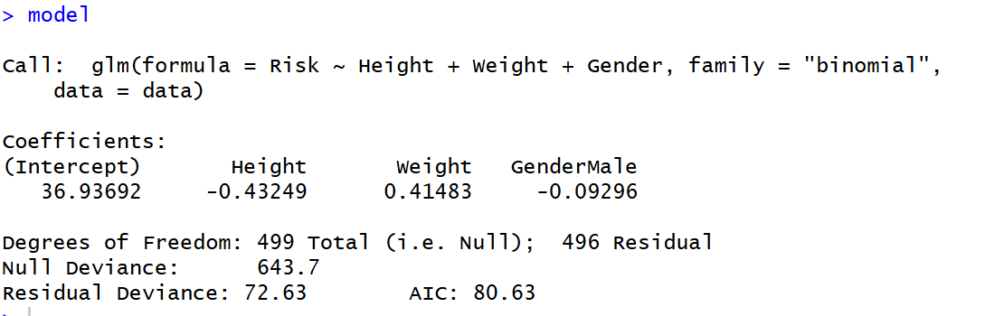
Interpretation-
- Height= (−0.432) Negative coefficient, As height increases, risk decrease.
- Weight (+0.415) Positive coefficient, As weight increases, risk increases
- Gender (−0.093) Very small effect Gender has very weak impact on risk
- Logistic regression analysis revealed that weight is positively associated with risk, while height shows a negative association. Gender does not appear to have a significant effect. The model demonstrates a strong fit, as indicated by a substantial reduction in deviance.
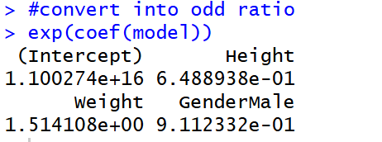
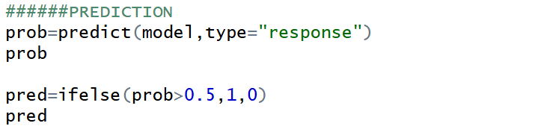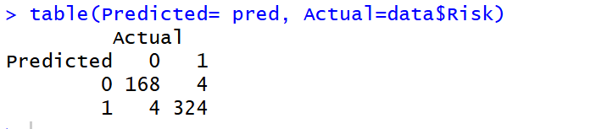

Conclusion
In this study, statistical methods were applied to analyze the relationship between height, weight, and gender with respect to disease risk. The results of the analysis showed that weight is a significant factor influencing risk, as there was a clear difference in mean weight between low-risk and high-risk groups.
The chi-square test indicated that there is no significant association between gender and risk. Logistic regression analysis further supported these findings, showing that weight has a positive effect on risk, while height has a negative effect, and gender has minimal influence.
The model demonstrated good predictive performance, as observed from the confusion matrix. Overall, the study suggests that weight is an important variable in determining risk, whereas gender does not play a significant role in this dataset.

